Name: ___________________________________________

**Blood and Circulation Webquest**

**PART I***: Introduction to the circulatory system*

Check out this link to investigate the role of the circulatory system in our bodies:

<https://my.clevelandclinic.org/health/body/21833-cardiovascular-system>

1. The cardiovascular system has a very important function ― getting o___________ and n_______________ to your entire body and removing w________________.

1. The two main components of the cardiovascular system are:
2. **True** / **False** (circle one) Your heart circulates about 2,000 gallons of blood every day.
3. How does the cardiovascular system help with other organs?

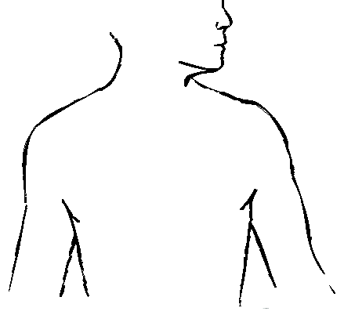

**PART 2***: A Closer Look at the Heart*

<https://www.healthywa.wa.gov.au/Articles/F_I/How-your-heart-works>

1. Click on the link above. Where is your heart located? Find the location of the heart and place a star on the body below where the heart is anatomically located.

<http://www.innerbody.com/image/card01.html>

6. Click the link and roll your cursor over the heart to IDENTIFY the parts of the human heart ***In addition, circle the part with a BLUE pen or pencil to represent DEOXYGENATED BLOOD and use a RED pen or pencil to represent OXYGENATED BLOOD.***

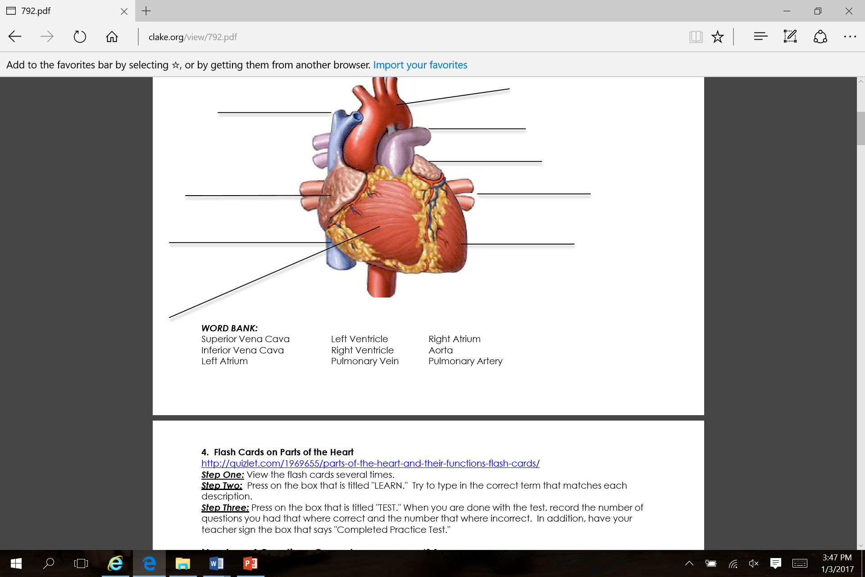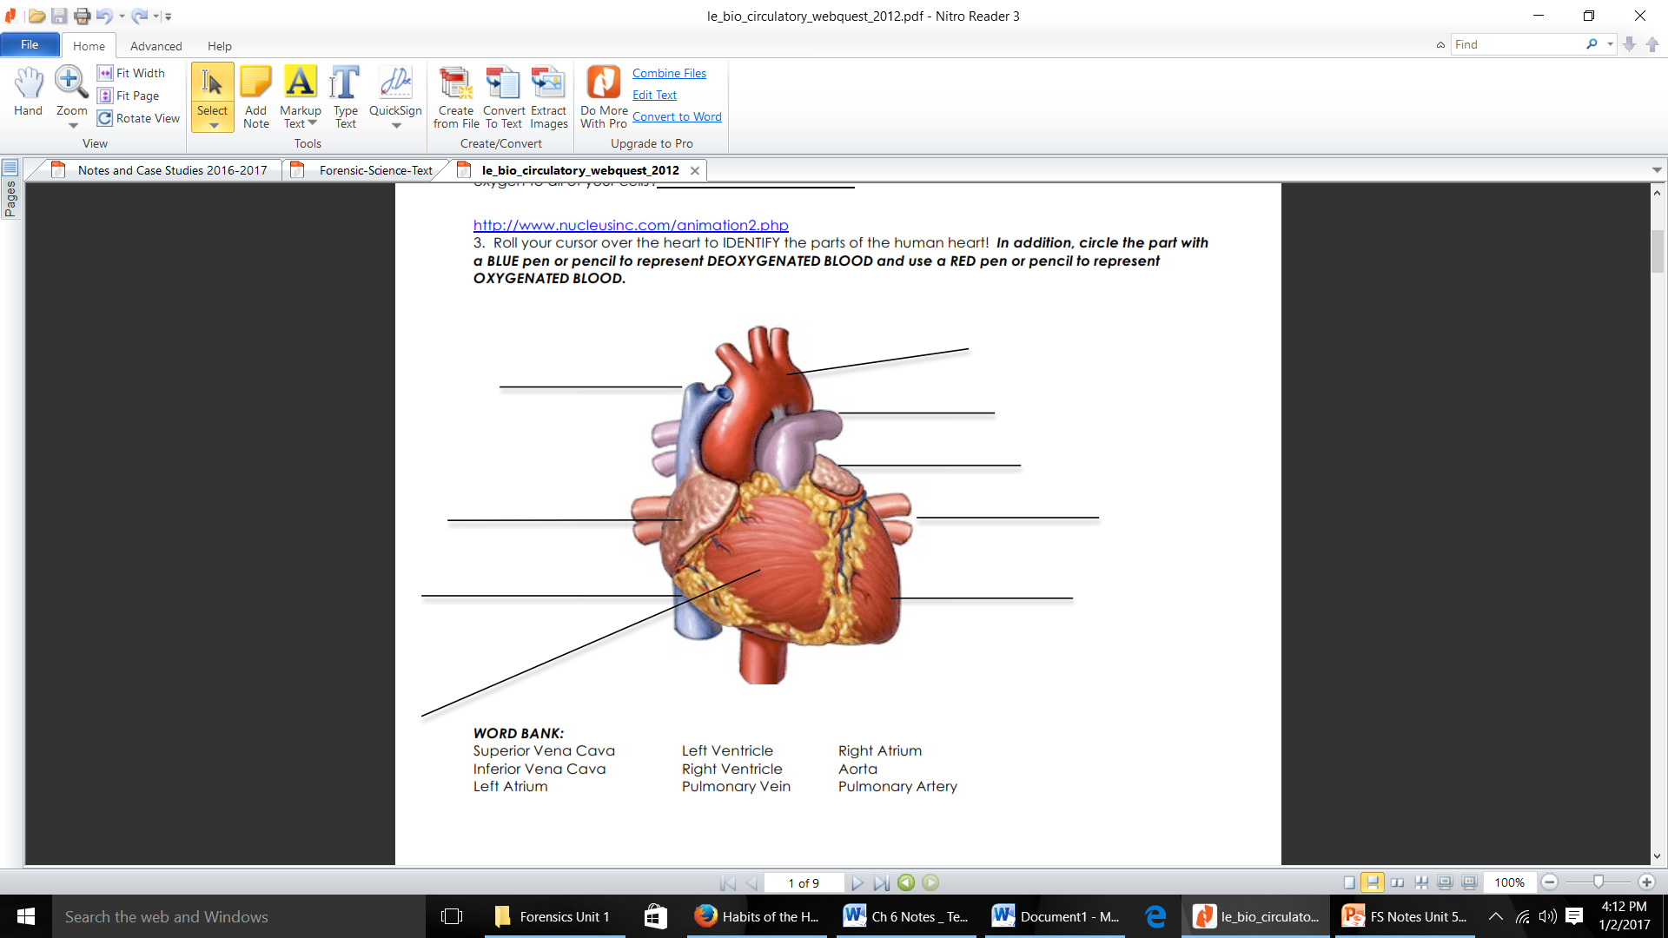

7. Flash Cards on Parts of the Heart <http://quizlet.com/1969655/parts-of-the-heart-and-their-functions-flash-cards/>

***Step One:*** View the flash cards a couple of times.

***Step Two:*** Press on the box that is titled "LEARN." Try to type in the correct term that matches each description.

***Step Three:*** Press on the box that is titled "TEST." When you are done with the test, record the number of questions you had that where correct and the number that where incorrect.

**Number of Questions Correct _____/14**

**Number of Questions Incorrect _____/14**

8. Practice will make perfect! Play the game in the link below to identify the parts of the heart below.

<http://www.purposegames.com/game/label-the-hearts-parts-quiz>

**NOTE:** You must click on "START" first! See how fast you can do it with 100% accuracy!

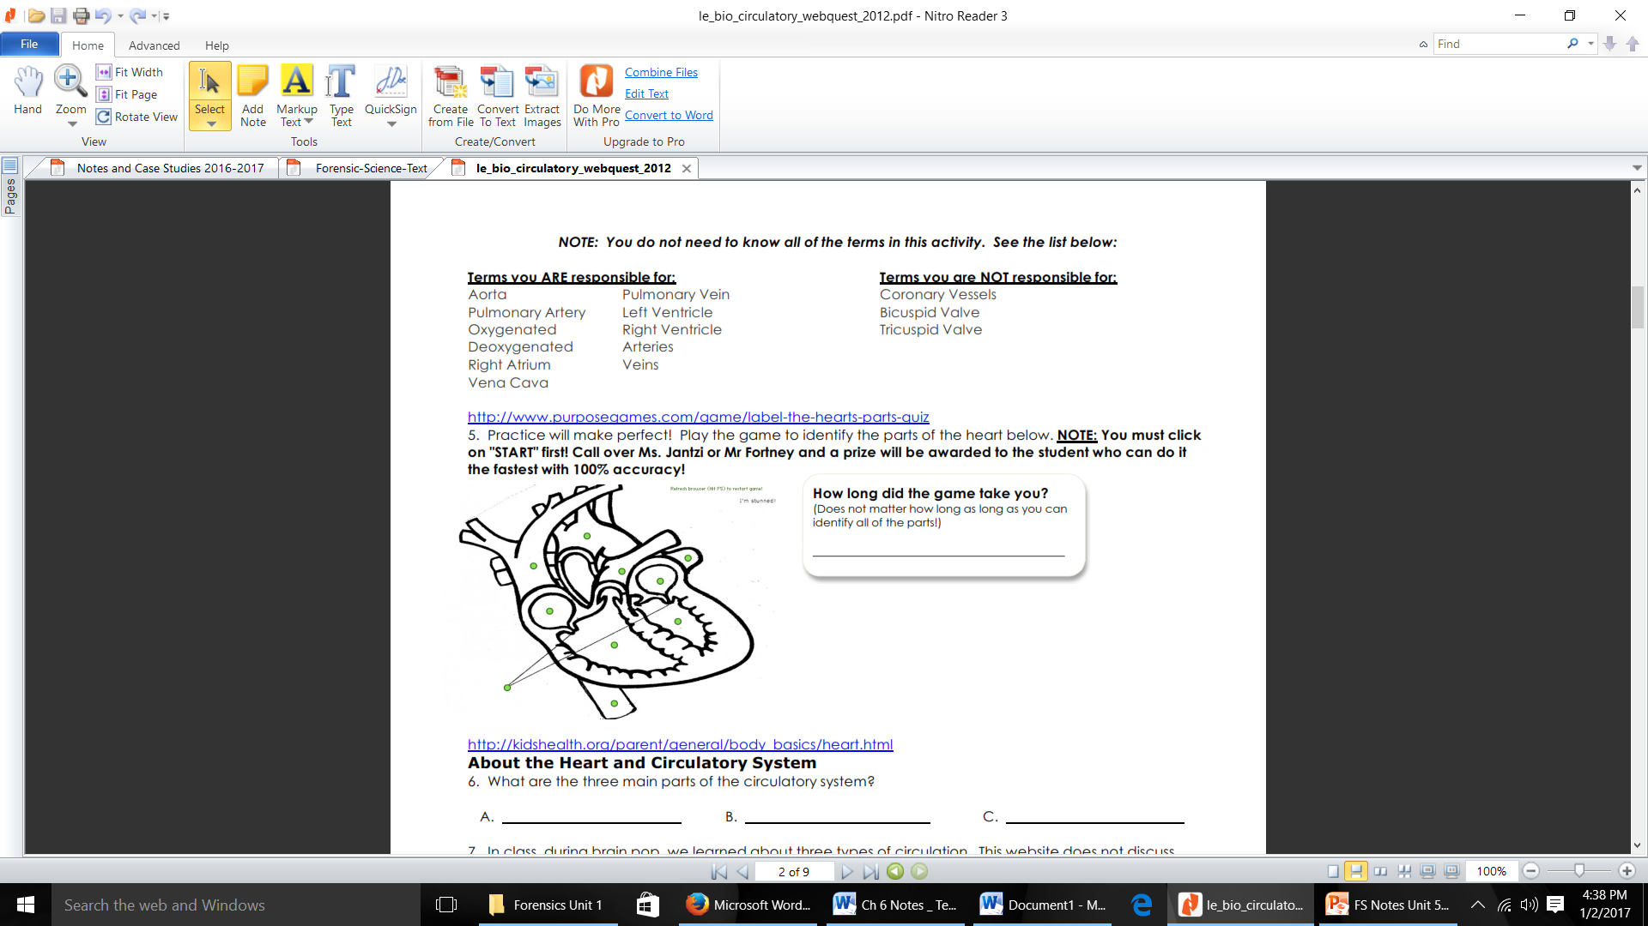

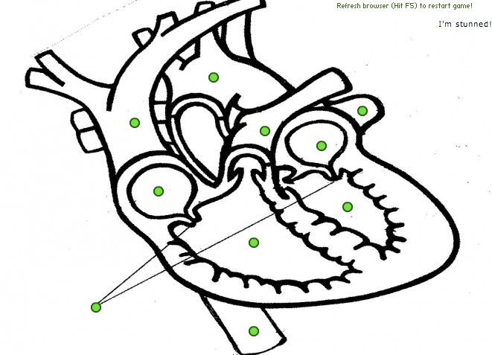

**PART 3***:* About the Heart and Circulatory System

Click here: ↓

<http://kidshealth.org/parent/general/body_basics/heart.html>

9. The function of the circulatory system is to: ____________________________________________

10. Humans have a ______________ chambered heart.

11. What are the two circulatory pathways?

P__________________________ S __________________________

12. Describe the following:

Pulmonary Circulation _________________________________________________________________

Systemic Circulation ___________________________________________________________________

13. What signals the heart to beat/contract?____________________________________________

14. What is the difference between systole and diastole?

_____________________________________________________________________________________________________________________________________________________________________________________________________________________________________________________________________

***View the animation of blood flow through the heart and fill in the blanks below:***

<http://www.heartpoint.com/theheart.html>

15. The _______________, receives "used blood" from the body. Blood will be pushed through the tricuspid valve to the _________________, the chamber which will pump to the lungs through the pulmonic valve to the __________________, providing blood to both lungs. Blood is circulated through the lungs where carbon dioxide is removed and oxygen added. It returns through the __________________________, which empty into the ___________________, a chamber which will push the __________Valve open. Blood then passes into the _______________________. This is the largest and most important chamber in the heart. It pumps to the rest of the body. As it pumps, the pressure will close the ___________ valve and open the aortic valve, with blood passing through to the ____________, where it will be delivered to the rest of the body.

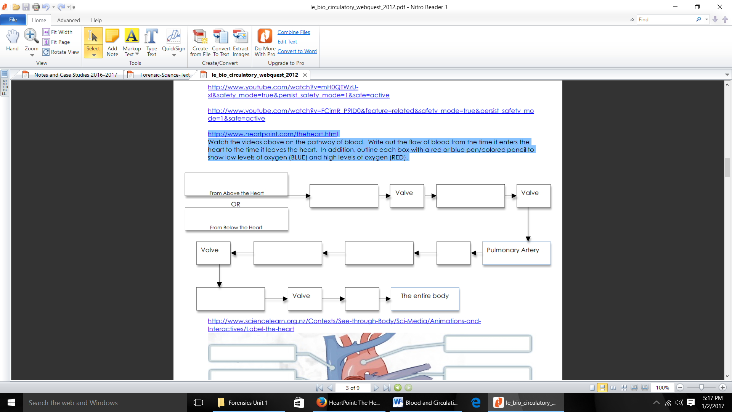16. Go through the link above on the pathway of blood. Write out the flow of blood from the time it enters the heart to the time it leaves the heart. In addition, outline each box with a red or blue pen/colored pencil to show low levels of oxygen (BLUE) and high levels of oxygen (RED).

Lungs

***Part 4:*** *Blood and Vessels*

<http://biology.about.com/od/humananatomybiology/ss/blood_vessels.htm>

17. Blood vessels are hollow tubes that transport [__________](http://biology.about.com/od/humananatomybiology/a/blood.htm) throughout the entire body.

18. These tubes are constructed of layers of ____________________________________________.

19. What is the difference between arteries and veins? __________________________________

_______________________________________________________________________________________

20. What process happens in the capillaries? ____________________________________________

21. One of the most common diseases of the arteries is __________________________________

<https://www.thoughtco.com/facts-about-blood-373355>

22. The color of blood is determined by the type of __________________ ________________ used to transport oxygen.

23. The adult human body contains approximately ____________ gallons of [blood](http://biology.about.com/od/humananatomybiology/a/blood.htm).

24. About ________% of the body's blood cells are produced in the ______________________.

25. Mature red blood cells do not contain a ______________.

26. The most common [blood type](http://biology.about.com/od/genetics/ss/blood-type.htm) in the United States is _______________. The least common is ________________________.

<http://www.webmd.com/hypertension-high-blood-pressure/guide/blood-pressure-causes>

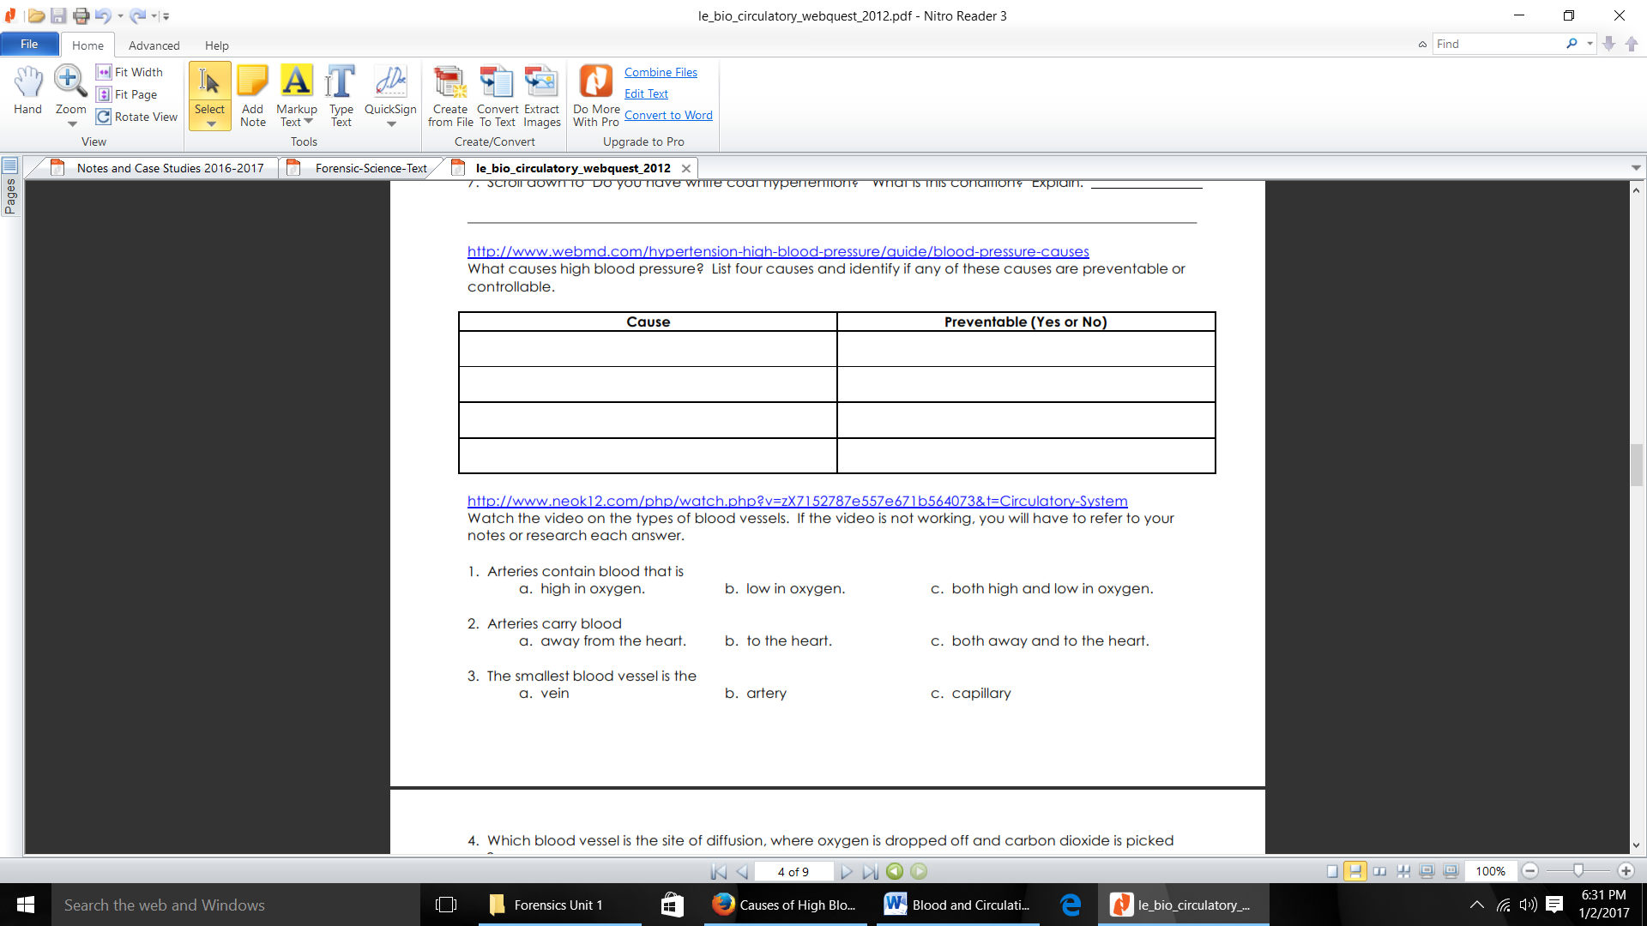27. Clinking on the link above, examine the causes of high blood pressure and if they are preventable or not.

28. Quiz yourself- See how well you have been paying attention so far:

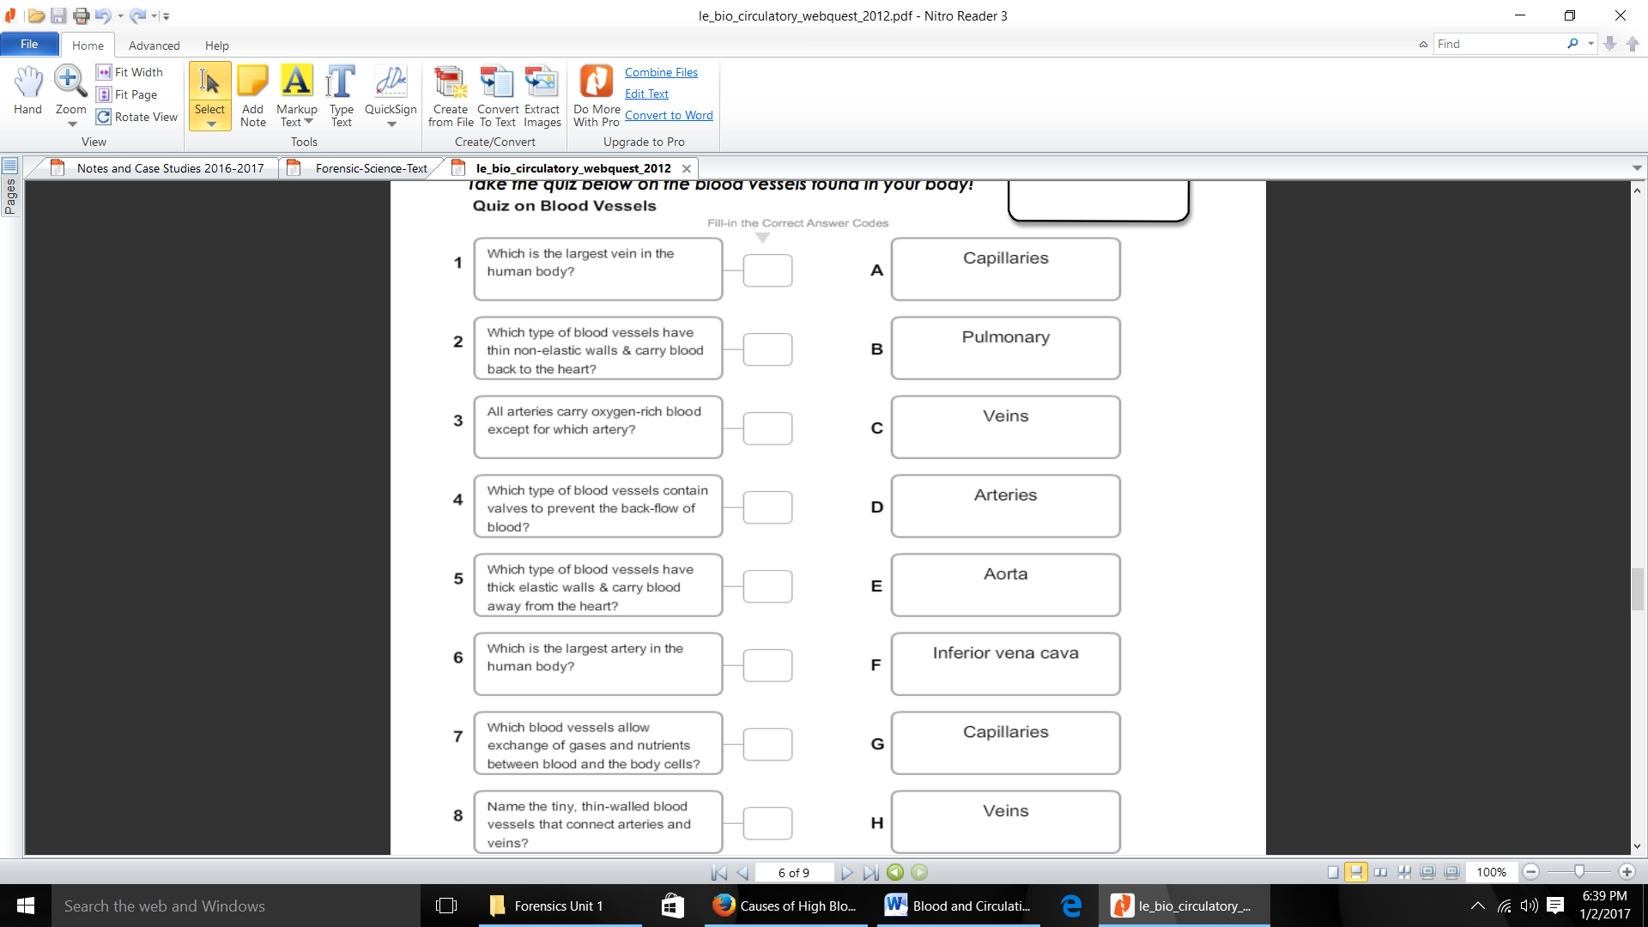

29. click on the link below to learn more about what makes up blood

<https://kidshealth.org/en/kids/blood.html>

|  |  |  |
| --- | --- | --- |
| **Component of Blood** | **Job** | **Looks like…** |
| Red Blood Cells |  |  |
| White Blood Cells |  |  |
| Platelets |  |  |
| Plasma |  |  |

30. Where are blood cells made? ______________________________________________________

31. How many blood types are there? __________________________________________________

32. Why is blood assigned a positive or negative? _______________________________________

_______________________________________________________________________________________

<http://www.wisc-online.com/objects/index_tj.asp?objID=AP14604>

**RED BLOOD CELLS-** Use the link above for some info on RBC’s

33. Blood is called the “River of life” because it carries __________________________________

34. ____________________ is the FLUID COMPONENT of blood and makes up ____________ %.

35. _____________________________________ makes up the remaining percentage of blood.

36. Red Blood Cells are also known as ______________________ . What is their main function?

_______________________________________________________________________________________

37. How are Red Blood Cells designed to perform this function? __________________________

_______________________________________________________________________________________

38. What is HYPOXIA or CYONOTIC mean? ______________________________________________

_______________________________________________________________________________________

39. How long are red blood cells active for? ____________________________________________

<http://www.sciencekids.co.nz/sciencefacts/humanbody/blood.html>

**Blood Facts**- Click on the link above for some interesting blood facts

40. Blood makes up around __________________ of the weight of a human body.

41. Blood contains ________________ , __________________and __________________________ .

42. These blood cells float in a yellow liquid called blood _________________. Blood ___________________ is made up of ____________________water and also contains various nutrients, electrolytes, gases, proteins, glucose and __________________.